(Please read Detail Manual from Questionnaire Website)
- Click npo.gov.bd
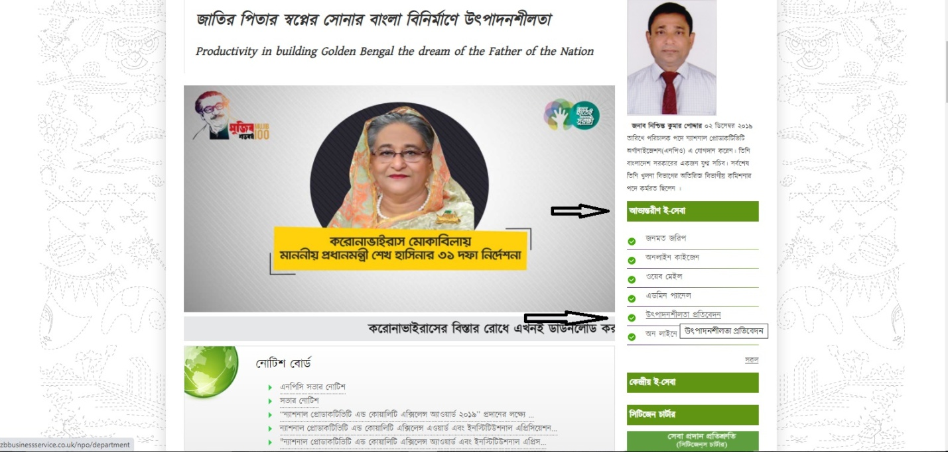

- Click on sugar tab (As Respective)

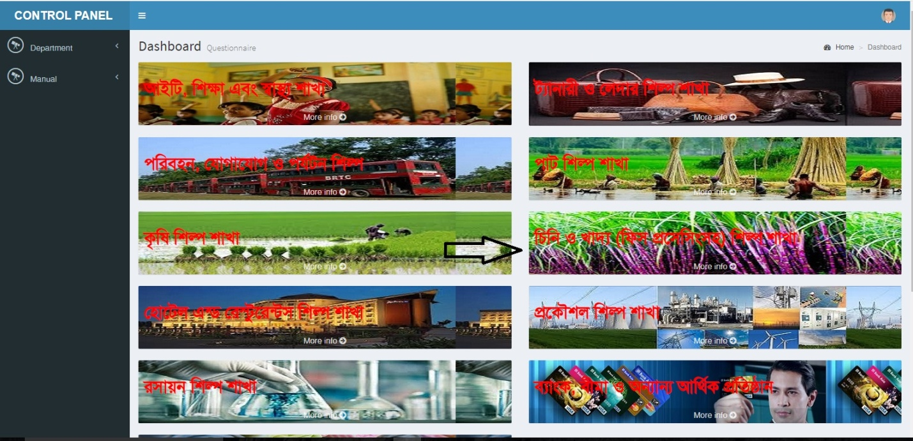

- Click and Create Managerial ID
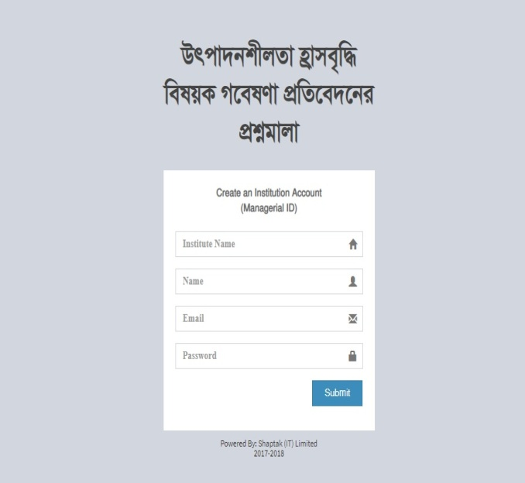
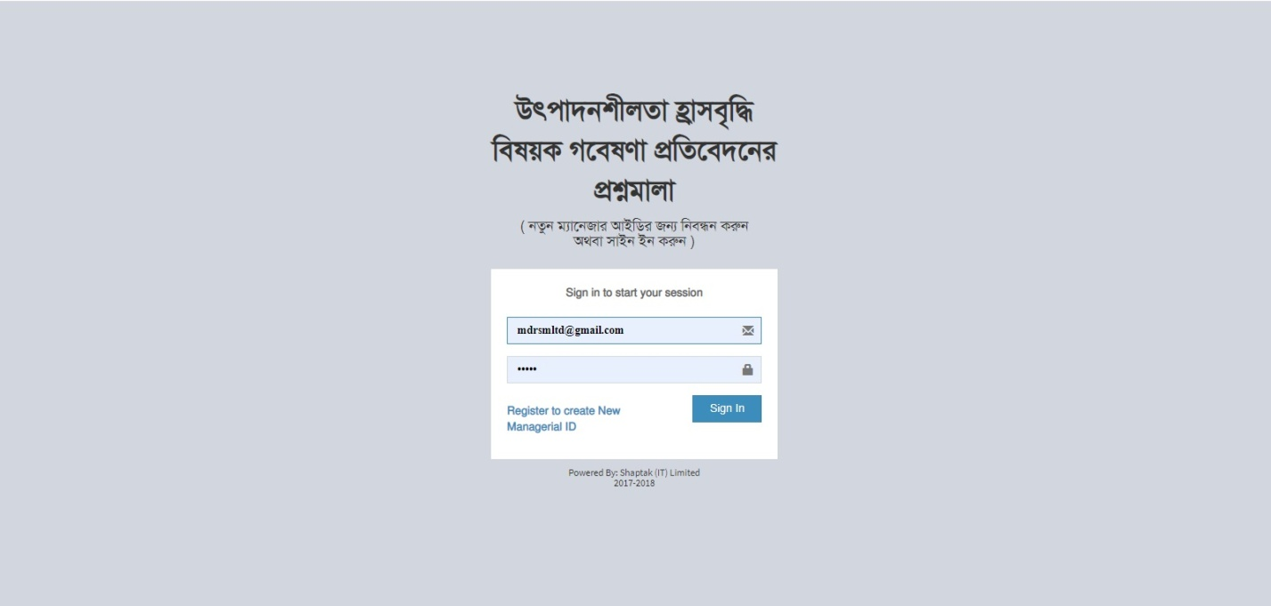

- Sign In with managerial ID and Password just created and create (Focal Point)- Click admin info - click create user

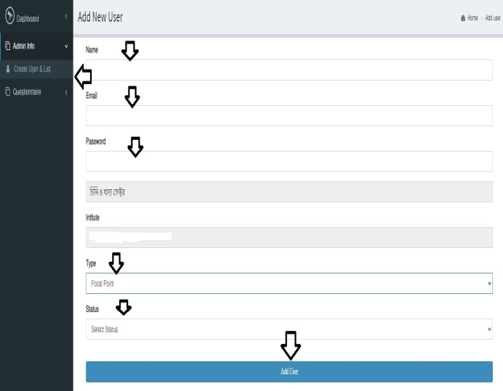

- Login with institute user same as above. Check the form, edit if needed and submit.
Note: Please check carefully before approve, you can not change after approve.

- Sign in with focal point user name and password

- Click Questionnaire click Sugar and food (as respective) click next fill up your form and submit.
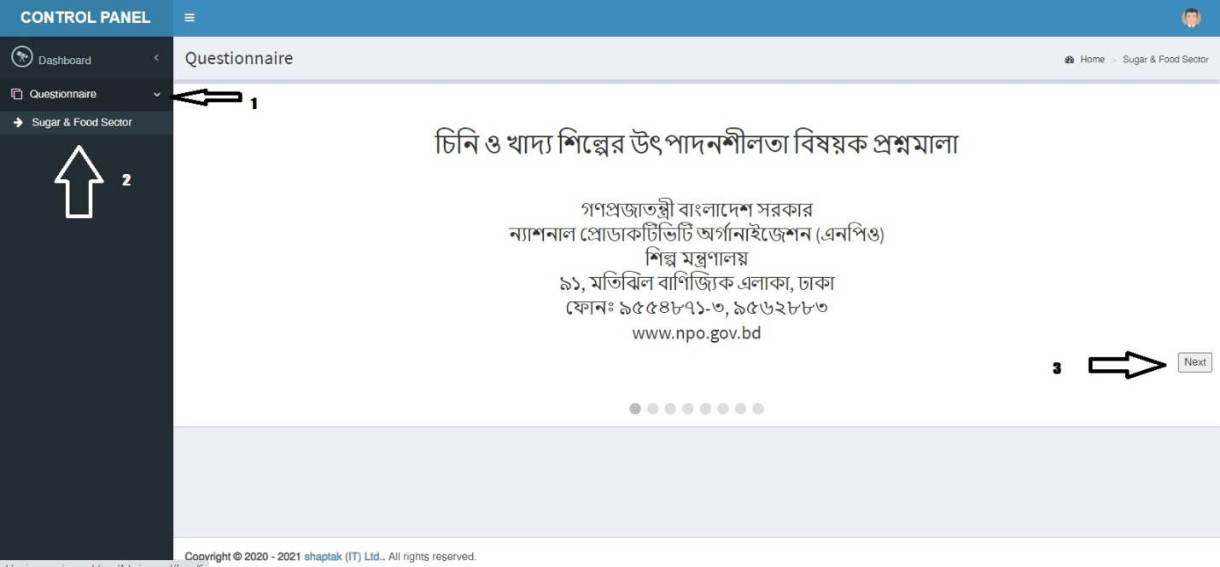

- Login with institute user again (same as above). Check the form, edit if needed and submit.
Note: Please check carefully before approve, you can not change after approval.

Thank You

